CPI 3.0 Training

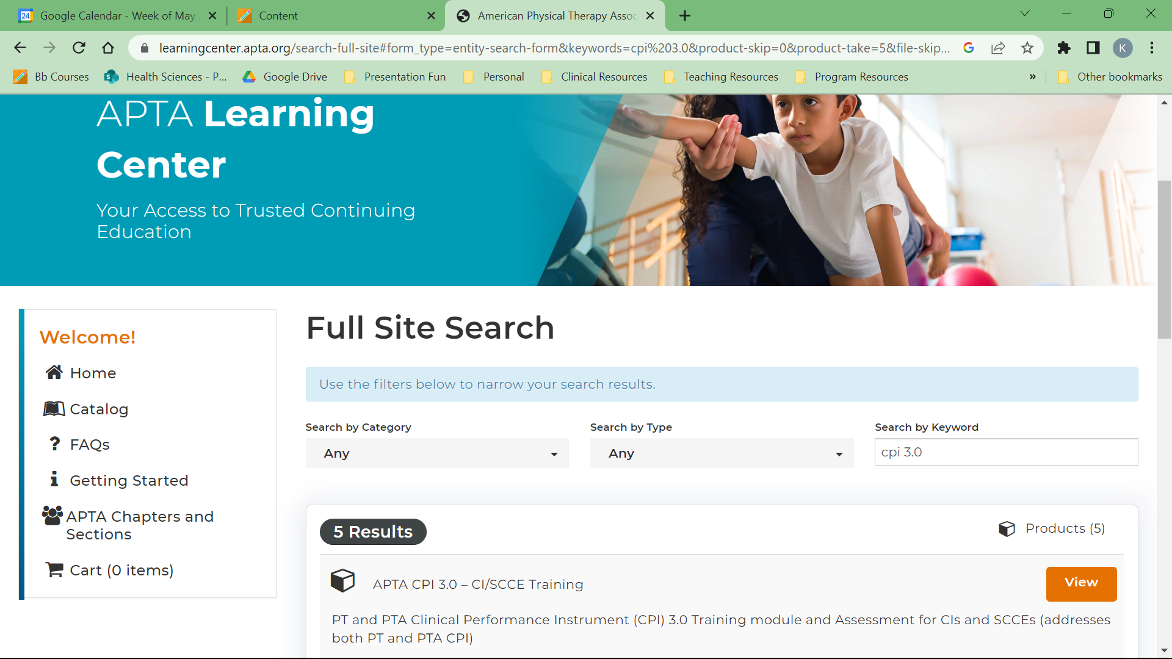
Training Requirement : Everyone who uses the CPI 3.0 must complete a new training for it. This training is on the APTA Learning Center webpage. Access it by searching the APTA Learning Center for “CPI 3.0”. Click on the “View” button for “APTA CPI 3.0 – CI/SCCE Training”, then “Register”. You will have to log in (to either your APTA account, if you’re a member, or into a guest account). Please let me know what e-mail address you use to log in (the CPI account I make for you must use the same email address).

  - The website for the CPI is now cpi.apta.org. Once you have completed the training and sent me your email address, I will create a new CPI account for you, which will allow you to access the site.

